***6|3|25* TEMPLATE CREATION**

**DAY 4**

**Create Book Detail Template**

Create 10 pages from above template make sure name and urls should be unique for each page eg-can search 10 books name on internet and can use

Create header it should have logo, Books, about me and reach me page for header we will need those above pages and should be created then use in navigation component inside header XF make sure Styling should be there from ui.frontend

footer should have 4 section 4x3 grid system

1. grid will have books pages created above
2. Grid will have about us
3. reach me section
4. Social media should have
5. should have copyright section and apply styling from ui.frontend and should be responsive

Create multi field component

**TOOLS->GENERAL->TEMPLATES**

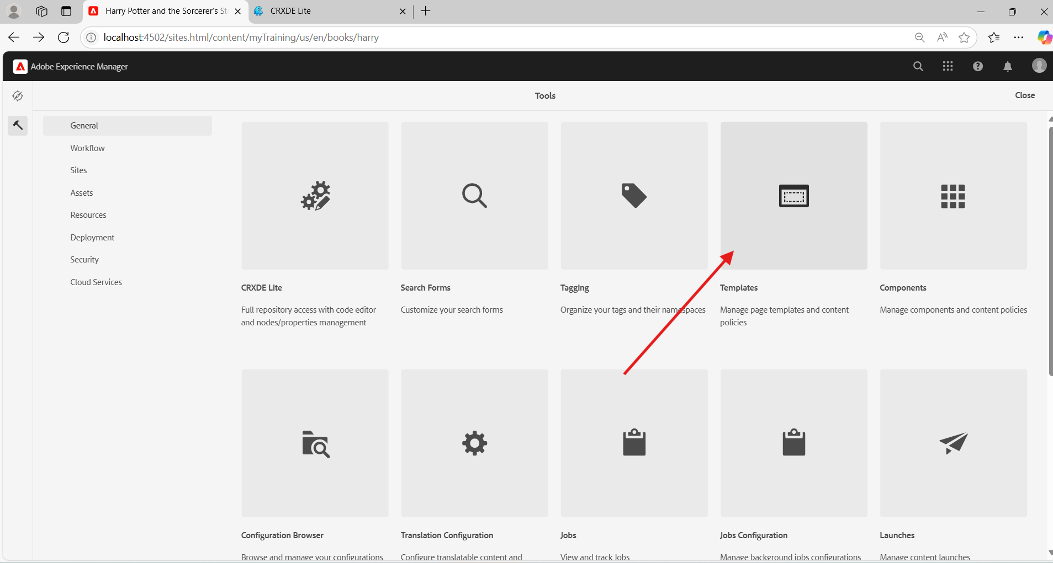

**CREATE BOOK-DETAIL TEMPLATE**

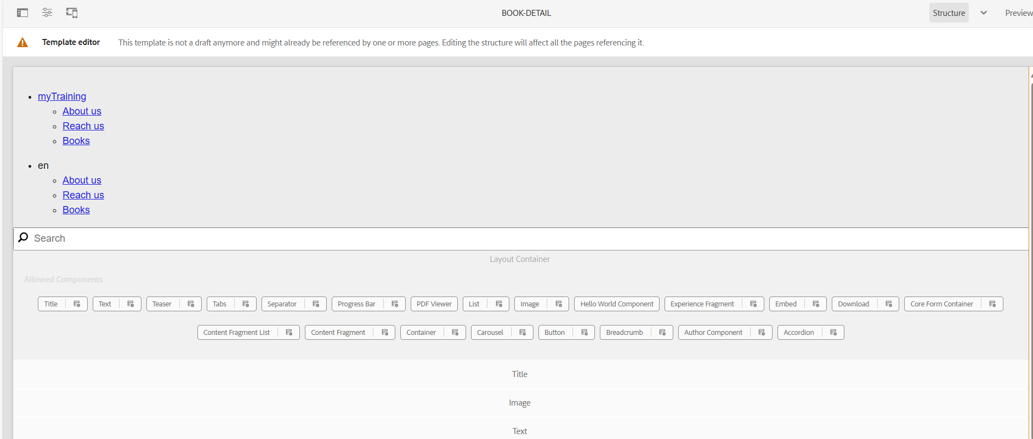

**ENABLE AND PUBLISH THE TEMPLATE**

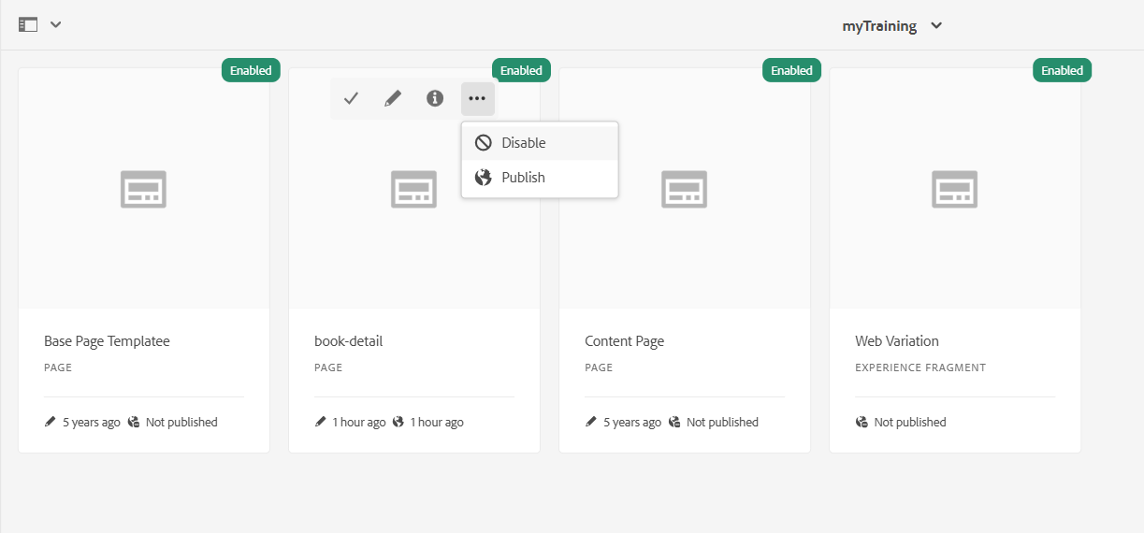

**SITES->MYTRAINING->US->EN**

**CREATE PAGES FOR ABOUTUS,REACHUS,BOOKS[Content page]**

**UNDER BOOKS CREATE 10 BOOK PAGES[Book-detail template]**

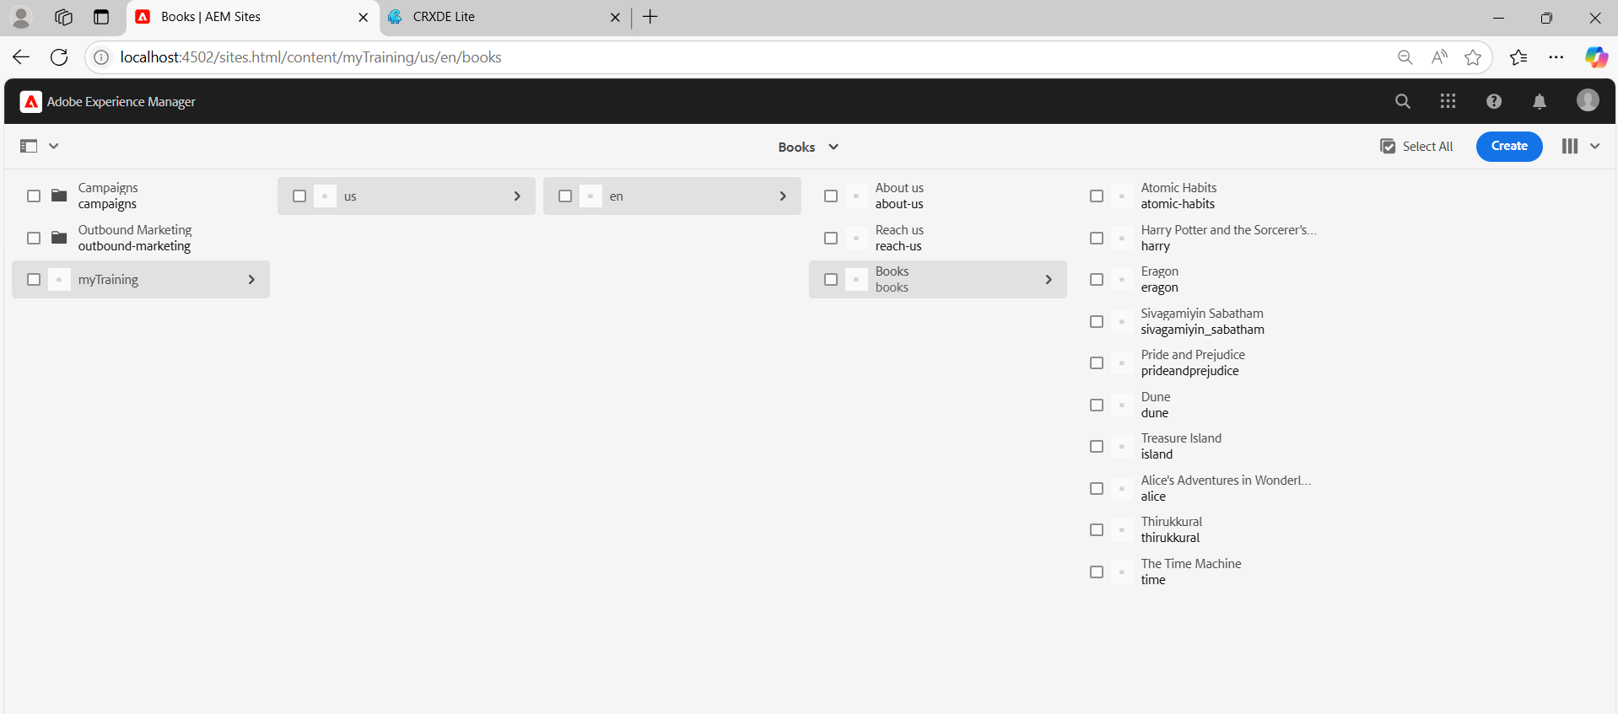

**HEADER WITH ABOUT US,REACH US,BOOKS**

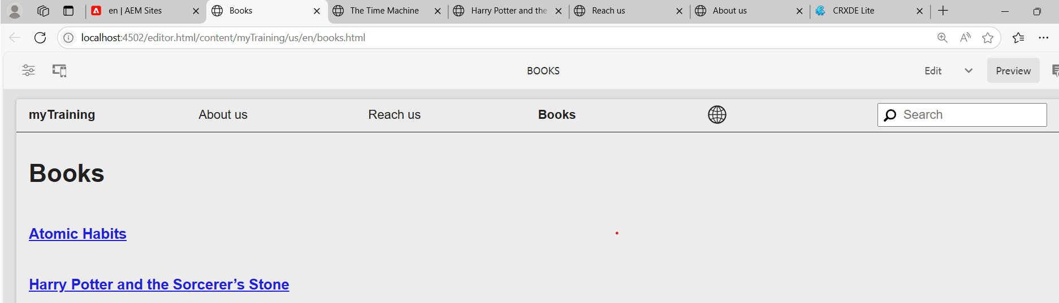

**ABOUT US**

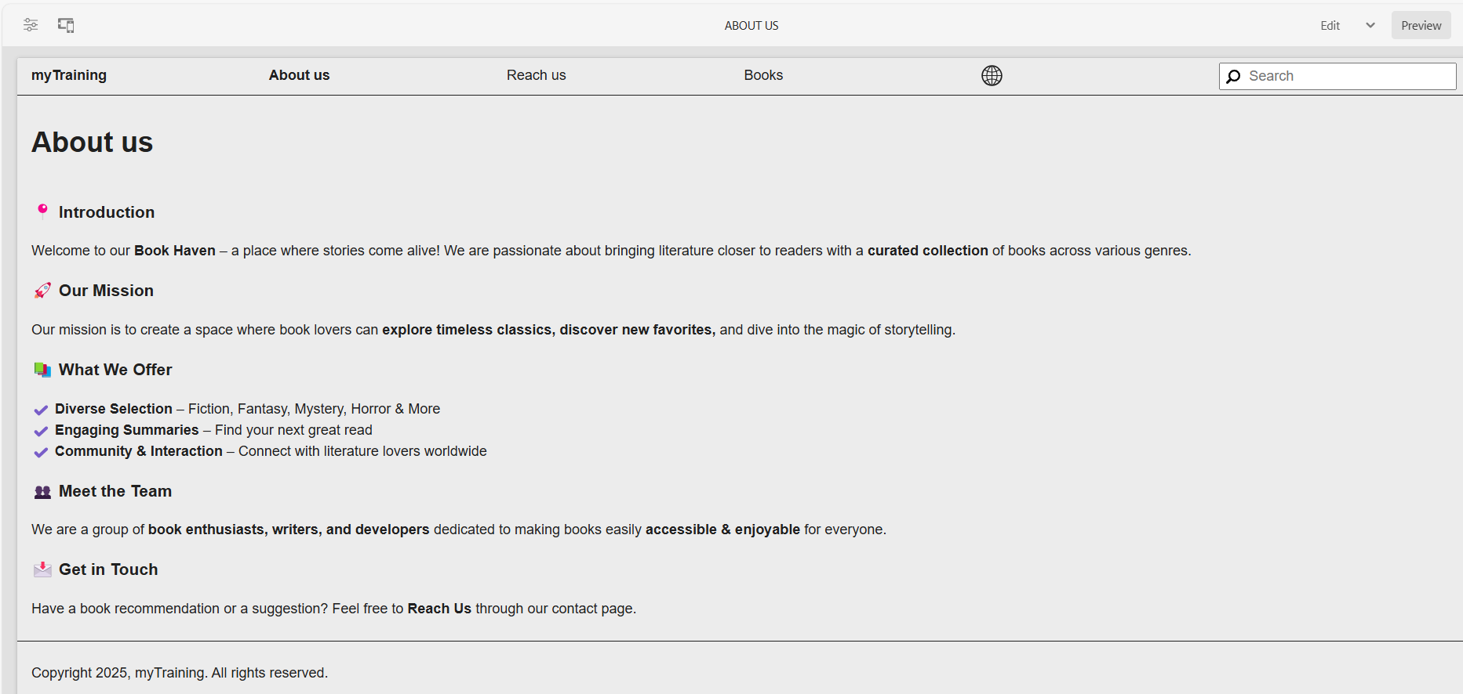

**REACH US**

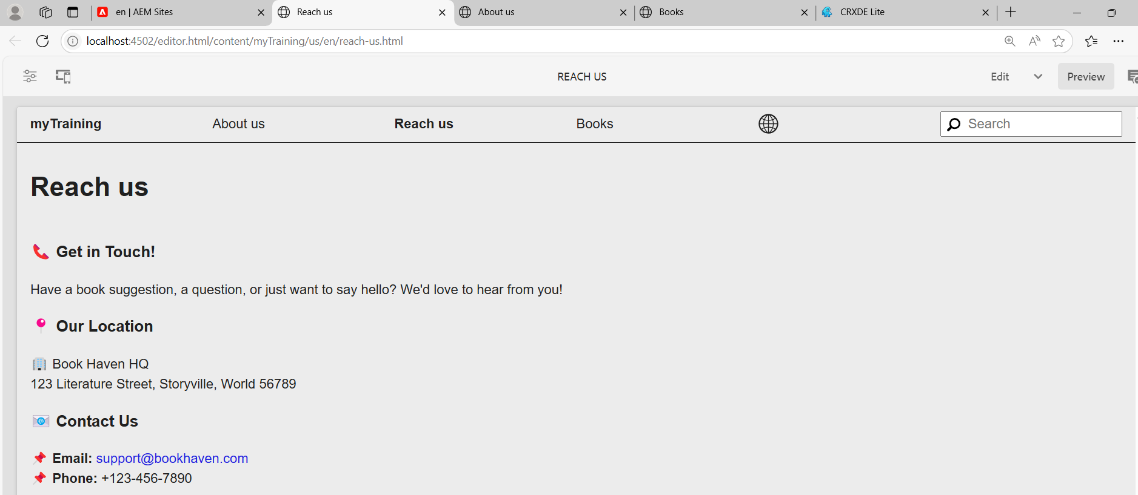

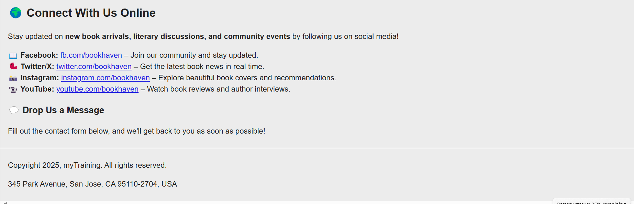

**BOOKS**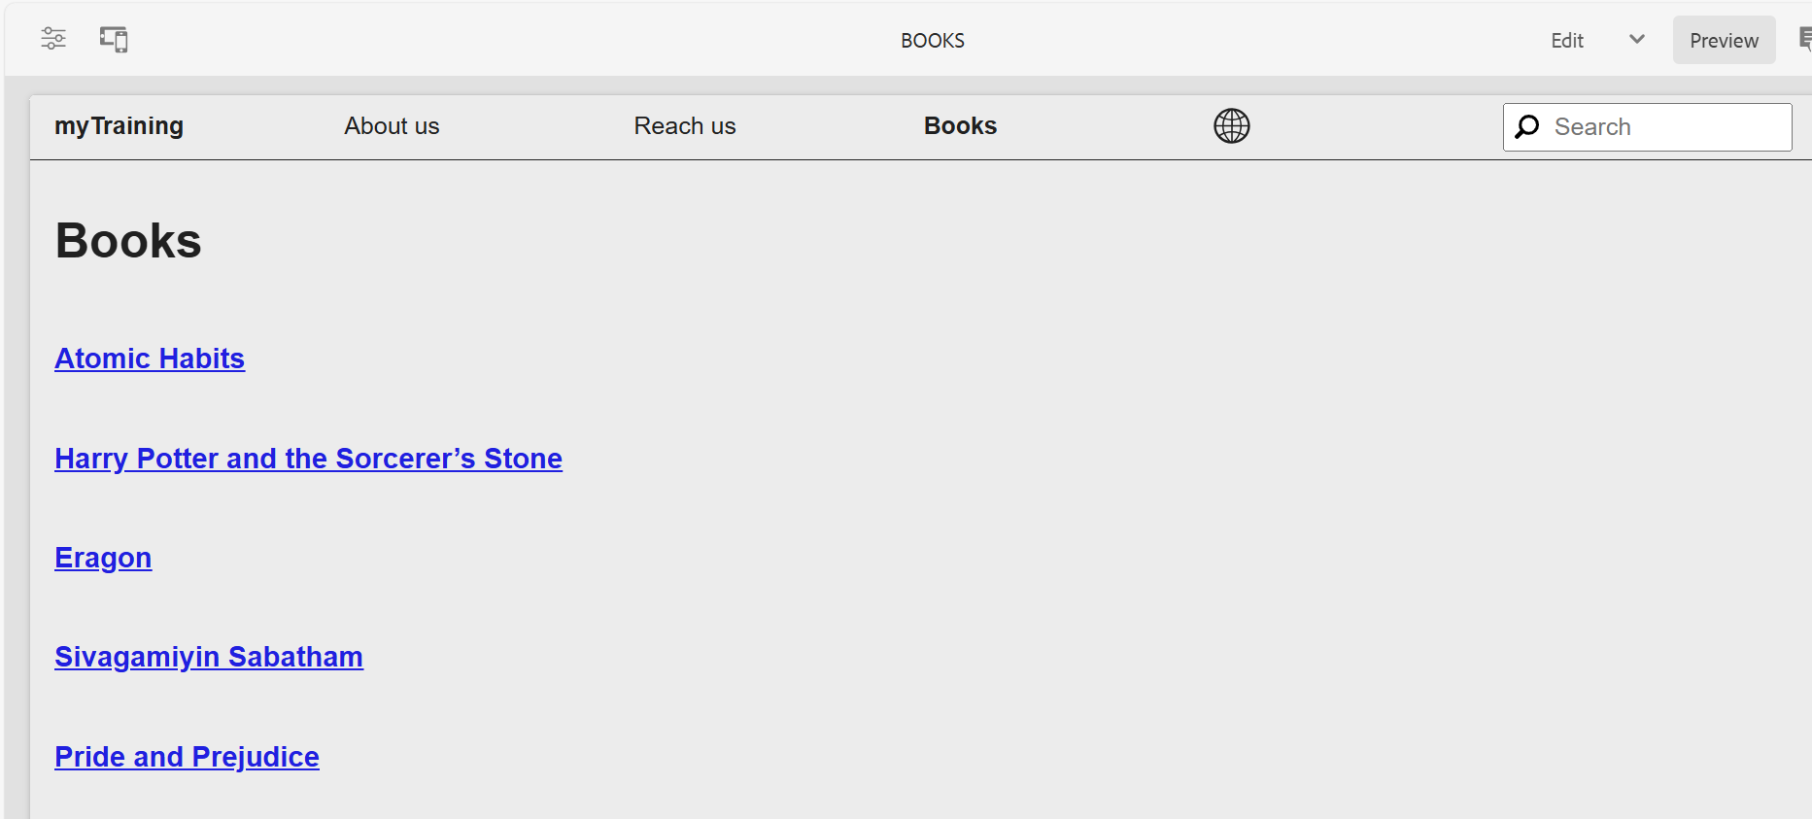

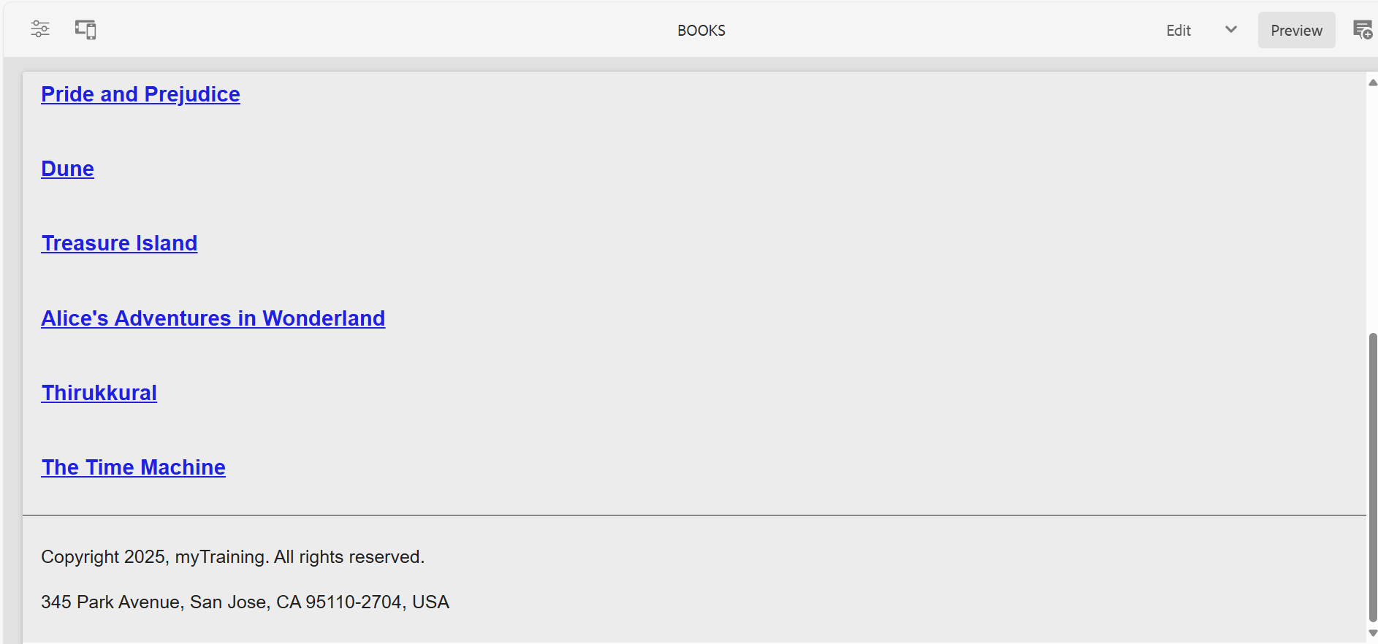

**SOME EXAMPLE BOOK PAGES**

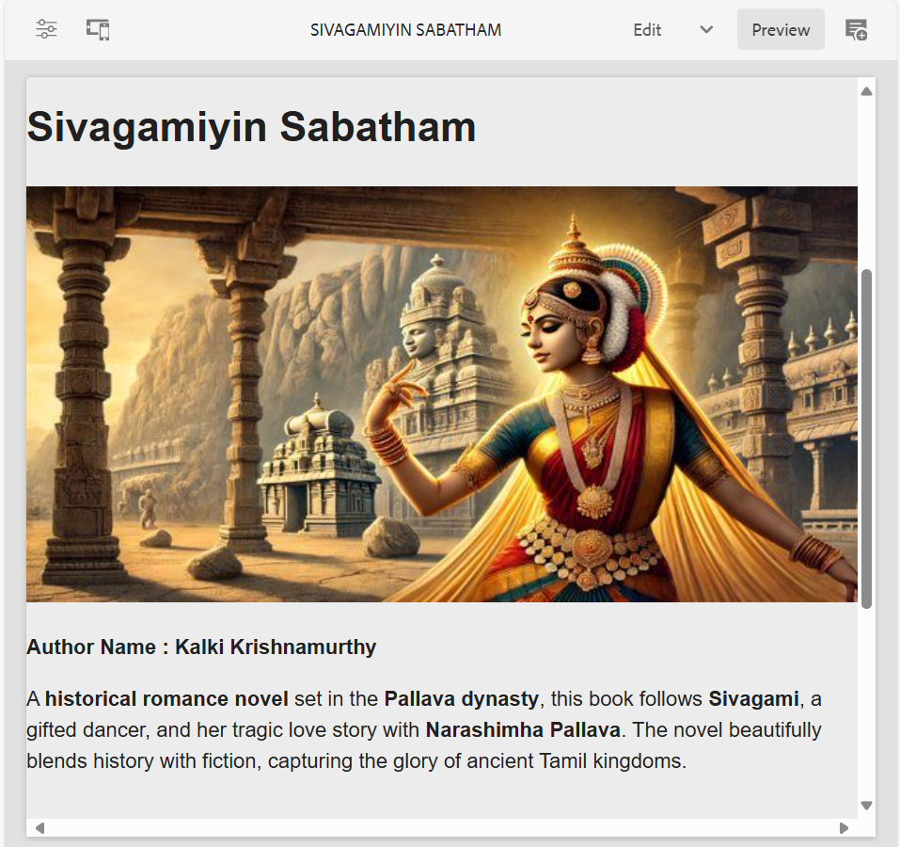

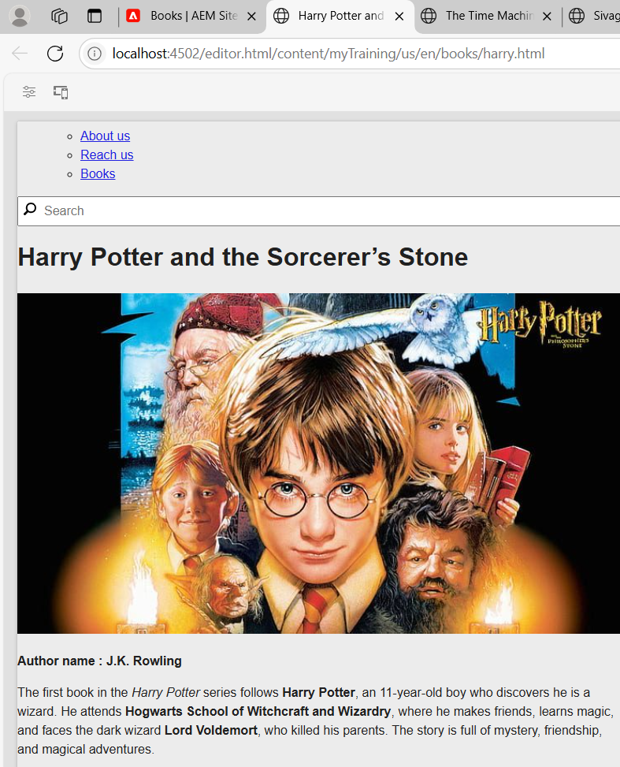

**SEARCH BAR**

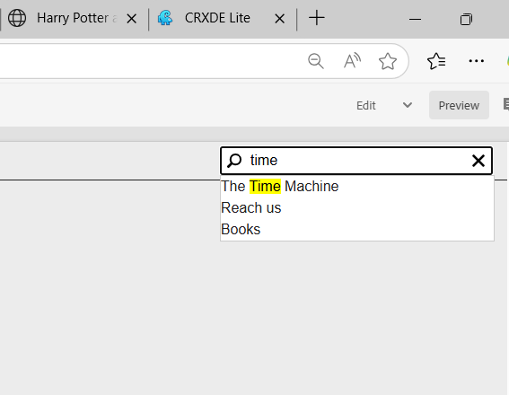

**ON CLICKING TIME MACHINE NAVIGATES TO THAT BOOK PAGE**

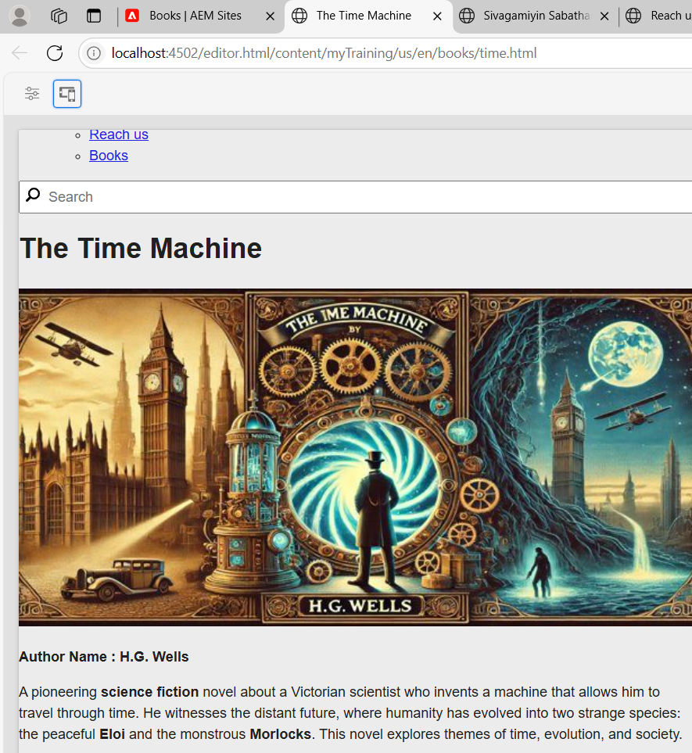

**FOOTER**

